

**Sehrish Mubarik**

**BSAIM-F23-001(4A)**

**Assignment no 04**

**Submitted to:**

**Sir Rasikh ali**

**Lab tasks 05**

**Question no 01**

**Open cv**

**Some outputs for open cv**

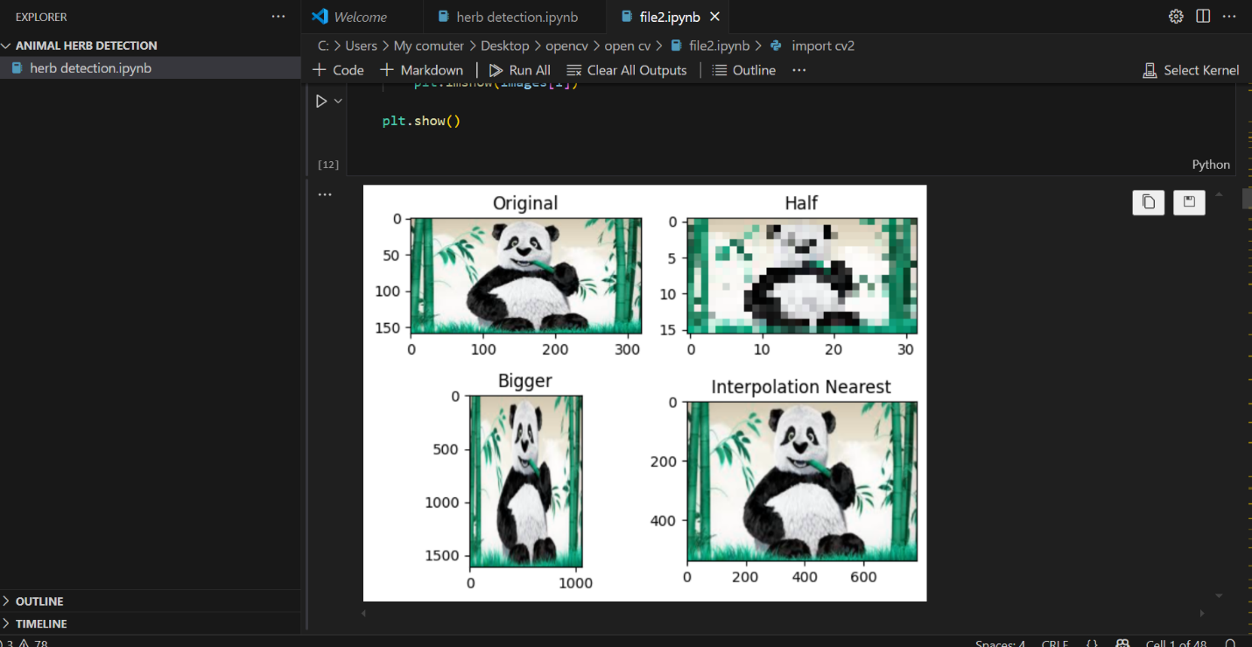

**2. output**

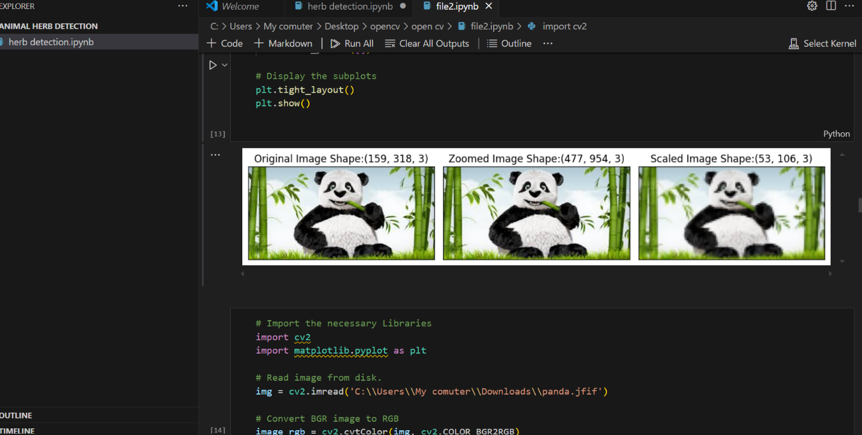

**3.output**

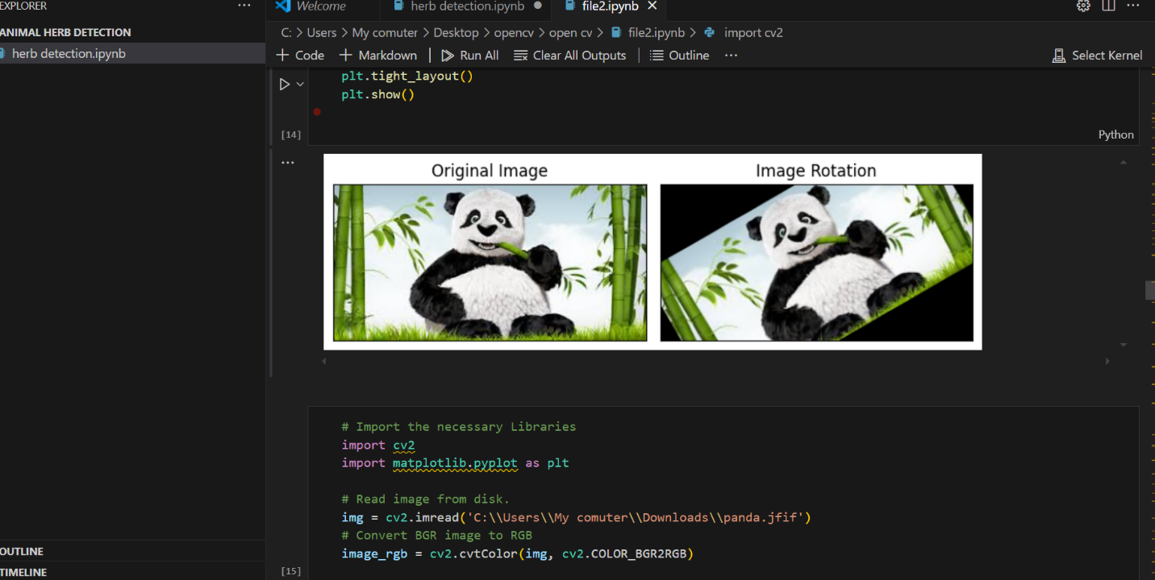

**4 output**

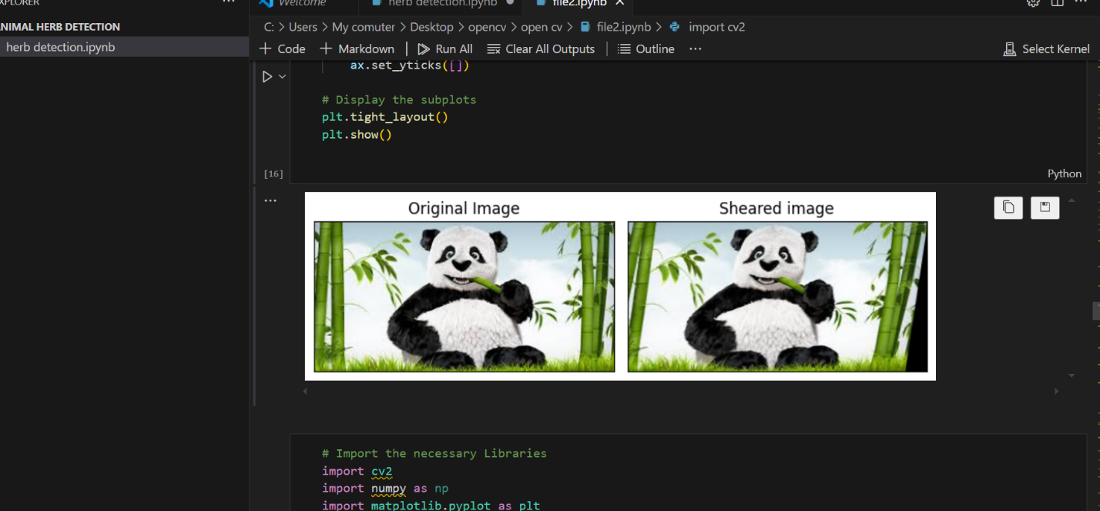

**The description.**

1. **Reading & Displaying Images**

* loads the image in full color (ignoring transparency).
* loads the image in black & white
* Displays the image in a window.
* Waits indefinitely until a key is pressed before closing the window
* Closes all OpenCV image display windows

1. **Image Shape & Properties**

* Returns the dimensions of the image (height, width, channels)
* indicates a colored image (3 channels for RGB).
* means it's a grayscale image

1. **Converting Color Spaces**

* Converts an image from BGR (default in OpenCV) to RGB (used in Matplotlib)
* Used for proper color representation when displaying with Matplotlib

1. **Displaying Images with Matplotlib**

* Displays the image using Matplotlib.
* Converts OpenCV's default BGR format to RGB for correct color representation.
* Waits for a user input before closing the image window.
* Closes all active Matplotlib windows.

1. **Grayscale Image Processing**

* Reads an image in **grayscale** using
* Displays it using OpenCV